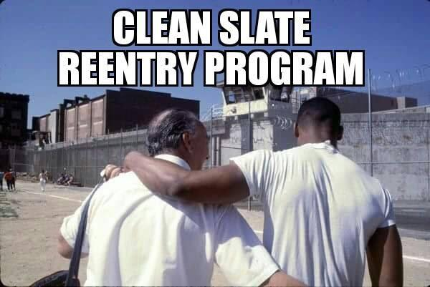

Clean Slate Reentry Program is a 4 month on site program, located in Sumter County, SC, that provides housing and other services for clients looking to reenter society in a productive manner and become successful. A person’s successful re-entry into society can be viewed through how adequately they are able to meet six basic life needs: livelihood, residence, family, health, criminal justice compliance and social connections. Those needs manifest differently, depending on the phase a client is in when they are released.

Clean Slate Reentry Program, which provides a full suite of services to returning citizens which includes housing, financial literacy, job training, job interview training, apprenticeships, employment, pardons, expungements and, where appropriate, help getting their driver’s licenses and voting rights back. These are some of the services that are offered upon enrollment in the program. **Our reentry program has no upfront fees and a 85% full time employment rate for our residents in the first 2 weeks of enrollment.**

If you are within 12 months of release, have minimal disciplinary actions while incarcerated, have not been convicted of crimes against women or children (no sex offenses), willing to commit to the 4 month program structure, and stay sober of drugs and alcohol, you may be a prime candidate for this program.

If interested, please request an application containing your reasons for wanting to enroll in the program, your skills and/or trades, educational level, and short & long term goals to:

Derek Gamble, Program Director

PO Box 271

Wedgefield, SC 29168